|  |
| --- |
|  |
| 新概念 3 册 |
| Lesson15 Fifty pence worth of trouble |

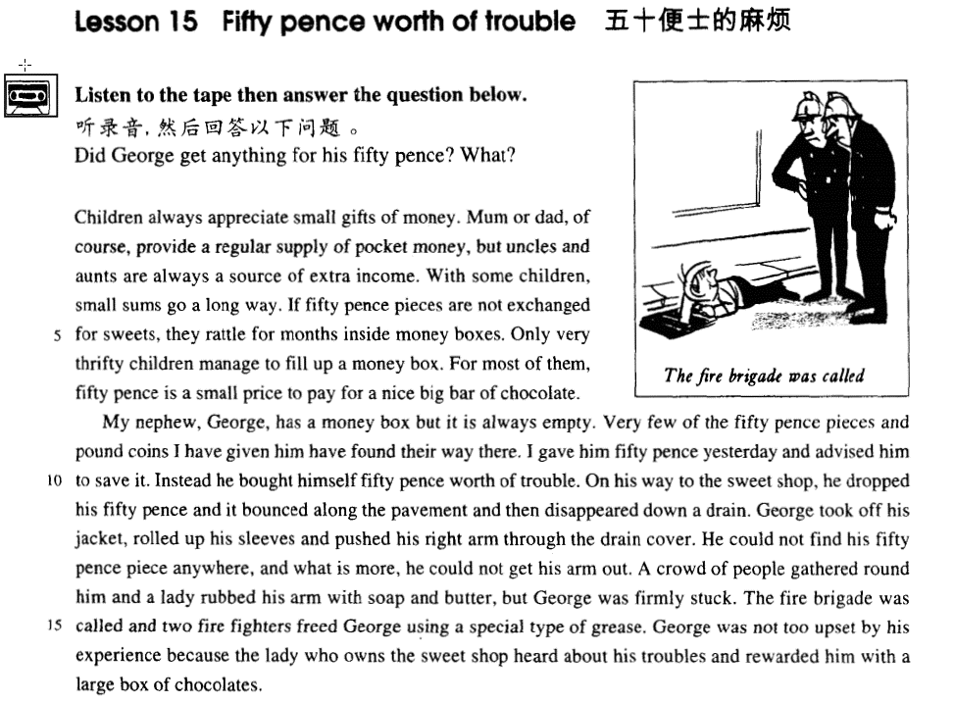

课文

Children always appreciate small gifts of money.

孩子们总是喜欢得到一些零花钱。

Mum or dad, of course, provides a regular supply of pocket money, but uncles and aunts are always a source of extra income.

爸爸妈妈当然经常给孩子零花钱，但是，叔舅婶姨也是孩子们额外收入来源。

With some children, small sums go a long way.

对于有些孩子来说，少量的钱可以花很长一段时间。

If 50 pence pieces are not exchanged for sweets, they rattle for months inside money boxes.

如果50便士不拿来换糖吃，则可以放在储蓄罐里叮当响上好几月。

Only very thrifty children manage to fill up a money box.

但是能把储蓄罐装满的只有屈指可数的几个特别节俭的孩子。

For most of them, 50 pence is a small price to pay for a nice big bar of chocolate.

对大部分孩子来说，用50便士来买一大块好的巧克力，是算不了什么的。

My nephew, George, has a money box but it is always empty.

我的外甥乔治有一个储蓄罐，但总是空空的。

Very few of the 50 pence pieces and pound coins I have given him have found their way there.

我给了不少50便士的硬币，但没有几个存到储蓄罐里。

I gave him 50 pence yesterday and advised him to save it.

昨天，我给了他50便士让存起来，

Instead, he bought himself 50 pence worth of trouble.

却拿这钱给自己买了50便士的麻烦。

On his way to the sweet shop, he dropped his 50 pence and it bounced along the pavement and then disappeared down a drain.

在他去糖果店的路上，50便士掉在地上，在人行道上跳了几下，掉进了阴沟里。

George took off his jacket, rolled up his sleeves and pushed his right arm through the drain cover.

乔治脱掉外套，卷起袖子，将右胳膊伸进了阴沟盖。

He could not find his 50 pence piece anywhere, and what is more, he could not get his arm out.

但他摸了半天也没找到那50便士硬币，他的胳膊反倒退不出来了。

A crowd of people gathered round him and a lady rubbed his arm with soap and butter, but George was firmly stuck.

这时在他周围上了许多人，一位女士在乔治胳膊上抹了肥皂，黄油，但乔治的胳膊仍然卡得紧紧的。

The fire brigade was called and two fire fighters freed George using a special type of grease.

有人打电话叫来消防队，两位消防队员使用了一种特殊的润滑剂才使乔治得以解脱。

George was not too upset by his experience because the lady who owns the sweet shop heard about his troubles and rewarded him with a large box of chocolates.

不过，此事并没使乔治过于伤心，因为糖果店老板娘听说了他遇到的麻烦后，赏给他一大盒巧克力。

词汇讲解

* **appreciate [ə'pri:ʃɪeɪt]** v. 欣赏；感激

appreciate music 欣赏

appreciate wine 欣赏

I appreciate your help. 感激

I appreciate it. 感激

**be appreciative of …** 感激的，感谢的

* I’**m** most **appreciative of** your concern for my health.

**in appreciation of …** 以感激…

* I sent him a gift in **appreciation** of his help.

**表达“感激的，感谢的”**

I’m **thankful / grateful to** you **for** your help.

I’**m** much **obliged** **to** you **for** your advice.

I’**m** deeply **indebted** **to** you **for** your encouragement.

I **owe** you (one).

I **owe** you a lot.

* I owe you a big favor. 欠一个大人情
* **pocket money ['pɒkɪt 'mʌnɪ]** n. 零用钱，零花钱

**pocket money** 给小孩的零用钱

**beer money** 给男人的零用钱

**pick one’s pocket**  （从口袋里）偷某人的钱

**pickpocket *n.*** 扒手

money burns a hole in one’s pocket (习语) 留不住钱

* **听力真题**

A) He doesn't have enough money to buy a printer now.

B) He's not sure how much a printer costs.

C) He'll buy a computer later this week.

D) He lost the money he was saving.

W: Have you saved enough to buy that new printer for your computer yet?

M: You know money seems to be burning a hole in my pocket lately. Maybe next month.

Q: What does the man mean?

Answer: (A) He doesn't have enough money to buy a printer now.

* **rattle** ['rætl] v. & n. 硬物碰撞时当当作响
* The coins **rattled** in the money box when he shook it.

**tinkle *n.*** 叮当声 ***vt.*** 使发清脆的声响 ***vi.*** 发叮当声

* I rang the bell and heard it **tinkle** inside.
* the **tinkle** of glass and china

**clatter *n.*** 哗啦声；嘈杂的谈笑声；咔嗒声 ***vi.*** 发出哗啦声；喧闹的谈笑 ***vt.*** 使卡搭卡搭的响

* the clatter of hooves 马蹄声

**chime *n.*** 钟声；一套发谐音的钟；和谐 ***vi.*** 鸣响；和谐 ***vt.*** 打钟报时；敲出和谐的声音

* The church bells chimed in the square.

**slam / bang**

* Don’t slam / bang the door.
* The door shut with a slam / bang.
* **thrifty** ['θrɪfti] adj. 节俭的
* a thrifty housewife

**frugal** ***adj.*** 节俭的；朴素的；花钱少的

**economical *adj.*** 经济的；节约的；合算的

**miserly** ***adj.*** 吝啬的；贪婪的

**stingy** ***adj.*** 吝啬的，小气的；有刺的；缺乏的

**wasteful** ***adj.*** 浪费的，不经济的；奢侈的

**extravagant** ***adj.*** 奢侈的；浪费的；过度的；放纵的

* …, he was so **extravagant** that he was always in debt.

**save on ...** 节约…

**economize on ...** 节约…

* **save on** water / electricity 节约用水/用电
* **economize on** water / electricity 节约用水/用电
* **nephew ['nefju:]** n. 侄子；外甥

**nephew**

**niece** ***n.*** 外甥女，侄女

**cousin *n.*** 堂兄弟姊妹；表兄弟姊妹

**sibling *n.*** 兄弟姊妹；民族成员

**sibling rivalry** 同胞争宠；同胞竞争

* He has two **siblings**, a brother and a sister.

**aunt** ***n.*** 阿姨；姑妈；伯母；舅妈

**uncle** ***n.*** 叔叔；伯父；伯伯；舅父；姨丈；姑父

**parental** ***adj.*** 父母亲的，父母的；亲代的，亲本的

**maternal** ***adj.*** 母亲的；母性的；母系的；母体遗传的

**paternal *adj.*** 父亲的；得自父亲的；父亲般的

* parental / maternal / paternal affection

**filial *adj.*** 孝顺的；子女的，当做子女的

**filial duty *na.*** 做女儿的义务；做儿子的义务

**filial piety** ***na.*** 孝道；孝顺

* **bounce** [baʊns] v. & n. 弹起，弹跳

**bounce = bound** v.& n. （同义）

* The ball **bounced** when it hit the ground.
* She came **bouncing** in and told me the good news.
* That’s **the way the ball bounces**. 本来就是这样的

**by leaps and bounds**: （习语）very quickly

* Her health is improving **by leaps and bounds**.
* **stick** [stɪk]v. 卡住；粘住；伸出
* The drawer **sticks** badly.

**表达“粘到…”**

**stick to …**

**cling to …**

**adhere to …**

* I’ll **stick to** my job until I find a better one.

stick your tongue. 深处舌头

stick’em up! 举起手来

* Freeze（不许动）! Stick’em up! Your money or your life? 回答：Definitely my life!

课文讲解

# Fifty pence worth of trouble

**短语复习：值多少钱**

**money + worth of + sth.**

* They had got away with **thousands of pounds worth of** diamonds. Ross: Well, how was the date?
* Rachel: Well I’m alone and I just bought **fifteen dollars worth of** candy bars, what do you think?
* I just bought 50 yuan worth of groceries.

# Children always appreciate small gifts of money.

**课文中表达“零花钱”同义替换**

Children always appreciate **small gifts of money**. Mum or dad, of course, provides a regular supply of **pocket money**, but uncles and aunts are always a source of **extra income.**

# Mum or dad, of course, provides a regular supply of pocket money, but uncles and aunts are always a source of extra income.

知识点（一）

**动词变名词的正式表达：**

… provides a regular supply of pocket money …

**greatly contribute to …** 对…做出贡献

➔> **make great contributions to …**

**specially emphasize / stress …** 特别强调

➔ > **lay / put special emphasis / stress on …**

**fully understand …** 完全了解…

➔ > **have a full understanding of …**

**carefully consider …** 仔细考虑某事

➔ > **give careful consideration to …**

**strongly object to …** 强烈反对某事

➔ > **have a strong objection to …**

* **造句**：这份报告特别强调了必须要吃充足的新鲜蔬菜和水果。
* The report specially stresses that it is necessary to eat plenty of fresh fruit and vegetables. （普通表达）
* The report lays special stress on the necessity of consuming adequate fresh fruit and vegetables. （高级表达）

知识点（二）

**source *n.*** 来源；水源；原始资料

* the source of the Yangtze River

**resource** ***n.*** 资源，财力；办法；智谋

* natural resources 自然资源
* mineral resources 矿物资源

**origin *n.*** 起源；原点；出身；开端

* the origin of mankind 人类起源
* the origin of the universe 宇宙起源

**originate in …** 起源于…

**stem from …** 起源于…

**have its roots in …** 起源于…

* Printing **originates in / stems from / has its roots** in China.
* However, a new type of humour, which **stems** largely **from** America, has recently come into fashion.
* **造句**：学习英语对我来说总是一种乐趣。
* Learning English is always **a source of** pleasure for me.

# With some children, small sums go a long way.

**with ... / for ... / to ...** 对某人来说

* **For** most of them, 50 pence is a small price to pay for a nice big bar of chocolate.

**go a long way** 延续很久

* The battery can go a long way.

**go a long way towards …** 在某个方面有很大的帮助

* The book will go a long way towards solving your problems.

**come a long way** 取得了很大的进步

* **托福听力真题**

(A)She traveled a long distance to attend the exhibit.

(B)She likes to paint a variety of things.

(C)She thinks her painting has improved.

(D)She's glad the man saw her students' paintings.

M: I saw some of your paintings at the student art exhibit. They are great.

W: Thanks. I feel as though I’ve **come a long way**.

Q: What does the woman mean?

Answer: (C) She thinks her painting has improved.

# If 50 pence pieces are not exchanged for sweets, they rattle for months inside money boxes.

知识点（一）

**piece**: coin 硬币

* Very few of the fifty pence pieces and pound coins I have given him have found their way there.

知识点（二）

**exchange A for B** 把A换成B，兑换

* Where can I exchange U.S. dollars for British pounds?

**exchange rate** 汇率

**change A into B** 把A变成B

* The witch changed the prince into a frog.

知识点（三）

**money boxes** 存钱罐

**piggy-bank** 存钱罐

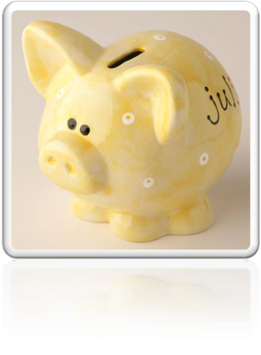

# Only very thrifty children manage to fill up a money box.

**fill up sth.** 把……装满， up是副词

**Fill her up!**

I need a full tank. 把邮箱装满

**fill in / out the form** 填表格

# For most of them, 50 pence is a small price to pay for a nice big bar of chocolate.

**be a small price to pay for sth.** 对于提…来说算不了什么

* **造句**: 损失点钱对于提高地位来说算不了什么。
* The loss of money **is a small price to pay for** the rise in status.

**be a high price to pay for sth.** 对于提…来说价格太高/不值得

* **造句**：为了成功而牺牲健康是不值得的。
* The sacrifice of health **is a high price to pay for** success.

a nice big bar of chocolate

**语法：形容词的顺序**

**大小 形状 年龄 新旧 颜色 国际 材料 用途 + 中心名词**

* **举例**：一张新的很沉的黑色的中国式的圆形的大木餐桌
* a heavy big round new black Chinese wooden dining table

**注意：名词前有量词，形容词放在量词前**

* a nice *cup* of tea 一杯好茶
* a beautiful *stretch* of field 一片美丽的田野
* a stagnant *pool* of water 一潭死水

**第一段写作总结：**长句为主，短句作为铺垫

* Children always appreciate small gifts of money. Mum or dad, of course, provides a regular supply of pocket money, but uncles and aunts are always a source of extra income. With some children, small sums go a long way. If 50 pence pieces are not exchanged for sweets, they rattle for months inside money boxes. Only very thrifty children manage to fill up a money box. For most of them, 50 pence is a small price to pay for a nice big bar of chocolate.

# My nephew, George, has a money box but it is always empty.

# Very few of the 50 pence pieces and pound coins I have given him have found their way there.

**find one’s way** 到达某个地方（主语必须是物）

* The river finds its way to the sea.
* How did my money find its way in your pocket?
* They had mysteriously found their way there from the wine cellar!
* Specially-made lanterns are hung outside each house to help the dead to **find their way**.

**lose one’s way** 迷路

* I love travelling in the country, but I don't like **losing my way**.

**feel one’s way** 摸索着前进

* The room was dark, so I had to **feel my way** along the wall to the door.

**make one’s way** 向某个方向走去

* The hospital had been bombed and Hans had **made his way** back into Western Germany on foot.
* Turning back down the main street, we quickened our pace and **made our way** rapidly towards the stream where we hoped the boatman was waiting.

**force / elbow one’s way** 从人群中挤过去

* He forced / elbowed his way through the crowd.

**trace one’s way** 蜿蜒前进

* We expected the path to end abruptly, but we found that it **traced its way** through the trees.

**edge one’s way** 侧身前进

* They had to **edge their way** along this, sometimes wading across shallow streams, or swimming across deep pools.

# I gave him 50 pence yesterday and advised him to save it.

**advise sb. to do sth.** 建议某人做某事

**advise (that) …** 虚拟语气

**语法：“should do”型的虚拟语气**

**1.下列动词后的宾语从句中用 (should) do**

**order**, **ask**, **decide**, **demand**, **require**, **advise**, **recommend**, **suggest**, **insist** …

* He **suggested** that we (should) help them with English.
* The teacher **ordered** that the homework (should) be finished within half an hour.
* Even though the noble was expected to read the letter at each performance, he always **insisted** that it should be written out in full.

**2.下列名词后的同位语从句中用 (should) do**

**suggestion**, **order**, **request**, **demand**, **proposal** …

* He made a **suggestion** that we (should) have a fancy dress party.
* The **proposal** that John (should) be dismissed is unacceptable.

**3.下列形容词后的主语从句中用(should) do**

**important**, **necessary**, **natural**, **essential**, **advisable**, **strange**, **surprising** ……

**表“应该”或“竟然”的时的用(should)do**

* It’s strange that you (should) say such a thing.
* It was important that you (should) tell me all the information.
* 课后习题讲解：

5. I gave him fifty pence yesterday and advised him he­­ ___B___ it. (11.9-10)

(a) saves (b) should save (c) would save (d) was saving

# Instead, he bought himself 50 pence worth of trouble.

课文省略，句子补全：

Instead of saving it, he bought himself fifty pence worth of trouble.

**instead of doing …** 本该……，结果却……

* **Instead of becoming a doctor**, however, he became a successful writer of detective stories.
* I**nstead of being five new family members**, these children had immediately become a commodity.
* **造句**：本该乘电梯的，我们却走楼梯下去的。
* Instead of taking the elevator, we walked down the stairs.
* **造句**：本该学习的，他却浪费时间追女孩子。
* Instead of studying, he wastes his time chasing girls.

# On his way to the sweet shop, he dropped his 50 pence and it bounced along the pavement and then disappeared down a drain.

**on one’s way** 在途中,在路上

**in one’s way** 挡住路

# George took off his jacket, rolled up his sleeves and pushed his right arm through the drain cover.

**push *vi.*** 推进；增加；努力争取 ***vt.*** 推动，增加；对…施加压力，逼迫；按；说服

**pull *vt.*** 拉；拔；拖 ***vi.*** 拉，拖；拔

**drag *vi.*** 拖曳；缓慢而吃力地行进 ***vt.*** 拖累；拖拉；缓慢而吃力地行进

**haul** 薅 ***vt.*** 拖运；拖拉 ***vi.*** 拖，拉；改变主意；改变方向

**写作细节：连续使用动词，可以表达一种急切的心情，增强紧迫感，好像节奏更快。**

* George took off his jacket, rolled up his sleeves and pushed his right arm through the drain cover.
* Acting on a sudden impulse, I collected several dozen, put them in a paper bag, and took them to Robert.

# He could not find his 50 pence piece anywhere, and what is more, he could not get his arm out.

**what is more / what’s more** 而且，还，（没有感情色彩，递进）

* What is more, they will not have to rely solely on the written word.

**表达“此外，而且”，（没有感情色彩）**

**moreover / furthermore**

**besides**

**in addition**

**additionally**

**表达“更糟的是…”，（有感情色彩）**

**to make things worse**

**to make matters worse**

* The team has lost the last two games and, **to make matters worse**, two of its best players are injured.

**语法注意**：非谓语动词如果是固定习语，不要考虑主语统一

# A crowd of people gathered round him and a lady rubbed his arm with soap and butter, but George was firmly stuck.

**gather** 文章中表示人群聚集

**assemble *vt.*** 集合，聚集；装配；收集 ***vi.*** 集合，聚集

**collect *vt.*** 收集；募捐 ***vi.*** 收集；聚集；募捐

**mass *vi.*** 聚集起来，聚集 ***vt.*** 使集合

**congregate *vi.*** 聚集 ***vt.*** 聚集

* While Alfred's little army slowly began to **gather** at Athelney, the king himself set out to penetrate the camp of Guthrum, the commander of the Danish invaders.
* A large crowd had **assembled** outside the American embassy.
* A crowd soon **collected** at the scene of the accident.
* Demonstrators had **massed** outside the embassy.
* A crowd quickly **congregated** around the speaker.

**a bar / cake of soap** 一块肥皂

**a slice of butter** 一块黄油

# The fire brigade was called and two fire fighters freed George using a special type of grease.

**the fire brigade** 【英式】消防队

**the fire department** 【美式】消防队

**fireman** 【英式】消防员

**firefighter** 【英式】消防员

**不好的写法：重心偏移,重点应突出救人**

… and two fire fighters used a special type of grease to free George.

# George was not too upset by his experience because the lady *who owns the sweet shop* heard about his troubles and rewarded him with a large box of chocolates.

**表示“获悉，听说”：**

**hear of / about …**

**know of / about …**

**learn of / about …**

**reward sb. with sth.** 奖励某人某事

* **造句：**观众们对这位表演者报以雷鸣般的掌声。
* The audience rewarded the performer with thunderous applause.

**a reward of ₤1,000** 一笔1000英镑的酬金

**award sb. sth.** 授予某个奖项

* She was awarded the Nobel Prize for her work in medical research. the Academy Award

# 总结

本文体裁：记叙文 (narrative)

文章线索：

题目：新颖有趣，引人注意

第一段：作铺垫：孩子喜欢零花钱→来源（父母/亲属）→少数节俭，多数立刻花掉第二段：叙述事情经过：(when, where, who, why, what, and result)，照应题目。